**A Project Report**

**On**

**NAME OF THE PROJECT**



**Submitted By**

Name:__________

Class: ________

Roll No.: ____________

**Session: 2022-2023**

**Under The Guidance Of**

Mr K. Jagannath Reddy

(Computer Science Teacher)

Department of Computer Science

Rabindra Vidya Niketan, Keonjhar, Odisha.

**Index Page**

|  |  |  |
| --- | --- | --- |
| **S.No.** | **Details** | **Page No.** |
| 1. | Acknowledgement | 1 |
| 2. | Certificate from supervisor | 2 |
| 3. | Front End & Back End used | 3 |
| 4. | List of Database and Tables used | 4 |
| 5. | Coding and Output | 5 to 10 |
| 6. | Applications of the Project | 11 |
| 7. | Bibliography / References | 12 |

**Acknowledgement**

I, __________________, student of class XII Sc. pay me sincere thanks to my teacher Mr. K. Jagannath Reddy (Computer Sc. Teacher) who has guided me to complete my project work. I have completed this task under his able guidance and cooperation of my group members is really helpful for me. My group members are ___________, ______________ .

Sign. Of student

**Certificate**

It is certified that the project work titled: **___________________________** is developed by ______________, ___________, ________________ in a group of 3 students. This project work is carried out to fulfill the partial requirement of **CBSE AISSCE Practical Exam 2023** for the subject **Computer Sc. New (083)**. This is my original work.

Student Sign. Teacher I/C Sign.

**Front-End and Back-End Used**

Front-End: -

Front-End is the development environment where we write the program code to develop the interface so that the user can communicate with the system. I have taken **Python 3.10.6** to develop the project. Using IDLE programs were developed and tested.

Back-End: -

Back-End refers to the database which is working in behind of front-end. It is used to store data. I have taken **MYSQL/Data** **Handling(Binary File/ CSV File)** as Back-End to store my data of students.

Both software used for developing project work is specified by CBSE and freely available as free and open source.

**List of Database and Tables Used**

I have created the following database and tables:

Database: _____________________

Table(s):________________________

Structure of Table: Student

|  |  |  |  |
| --- | --- | --- | --- |
| REGN | INT(5) | NOT NULL | PRIMARY KEY |
| NAME | CHAR(20) |  |  |
| CLASS | INT(3) |  |  |
| GENDER | CHAR(2) |  |  |

**Coding**

**Project Welcome View**

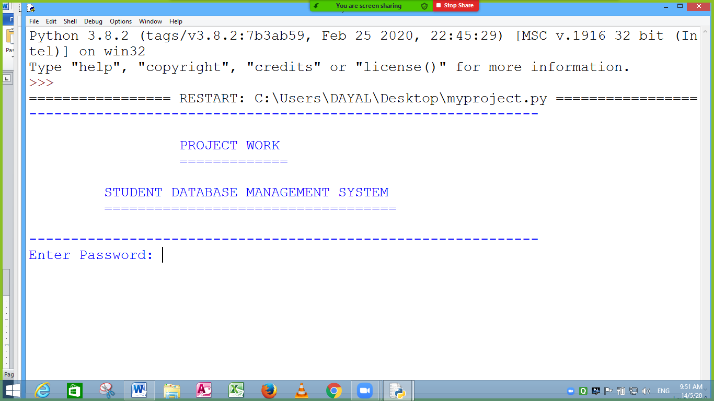

while (True):

print("-------------------------------------------------------------")

print(" ")

print(" PROJECT WORK ")

print(" ============= ")

print(" ")

print(" STUDENT DATABASE MANAGEMENT SYSTEM ")

print(" =================================== ")

print(" ")

print("-------------------------------------------------------------")

pw=input("Enter Password: ")

if (pw=="123"):

print("Correct Password")

break

else:

print("Incorrect Password ")

print("Please! Try Again ")

continue

**View of Menu System**

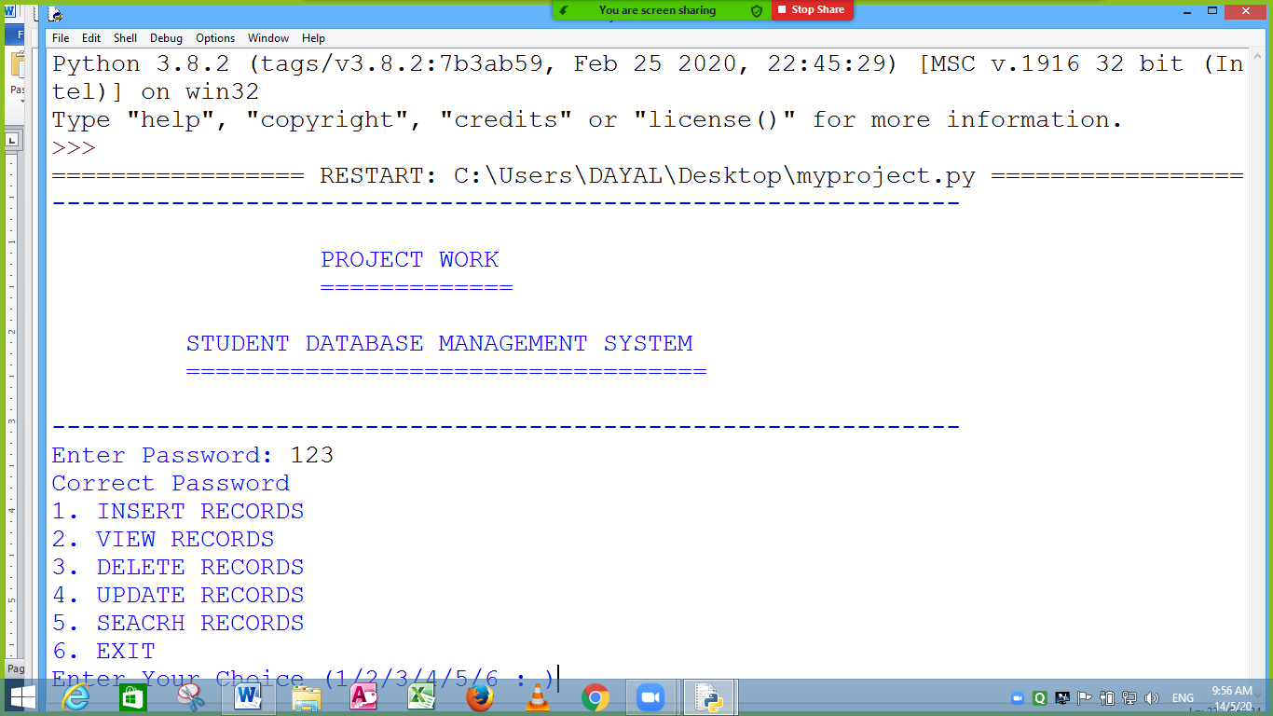

c='y'

while (c=='y' or c=='Y'):

print("1. INSERT RECORDS ")

print("2. VIEW RECORDS ")

print("3. DELETE RECORDS ")

print("4. UPDATE RECORDS ")

print("5. SEACRH RECORDS ")

print("6. EXIT ")

ch=int(input("Enter Your Choice (1/2/3/4/5/6 : )"))

if ch==1:

Rec_Insert()

elif ch==2:

Rec_View()

elif ch==3:

Rec_Delete()

elif ch==4:

Rec_Update()

elif ch==5:

Rec_Search()

else:

break

c=input("\n Do you want to continue y/n :")

**Applications of Project Work**

This project work can be used in any educational organization to maintain the student records. It is helpful to keep data updated and queries related to students can be solved with in few time.

**Bibliography / References**

I have used the following reference to complete my project work.

* Offline Classes by the teacher.
* Website: [www.python.org](http://www.python.org)
* Books Referred:- Computer Sc. With Python by Preeti Arora
* Books Referred:- Computer Sc. With Python by Sumita Arora